MySQL Assignment No. 2

Q1) Create the tables Member, Books, and Issue WITHOUT constraints.
Q2) Display the structure of all three tables using DESC.
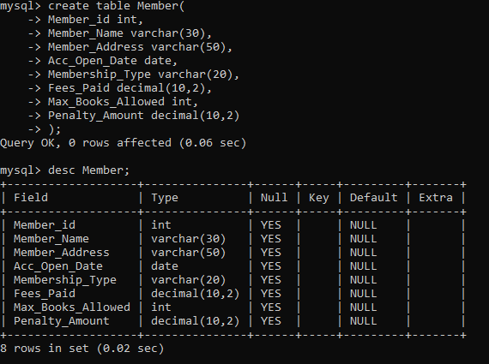
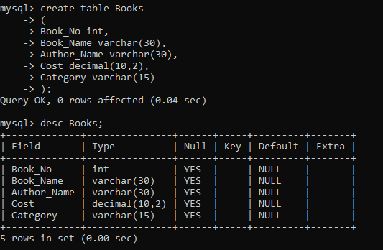
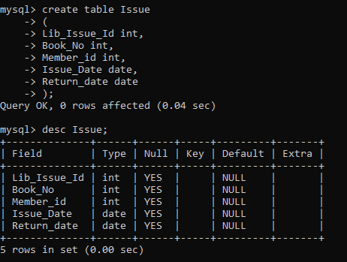
Q3) Drop the Member table.

Q4) Create the Member table again with these constraints:
- Member_Id must be PRIMARY KEY
- Membership_Type must allow only ('Lifetime','Annual','Half Yearly','Quarterly')
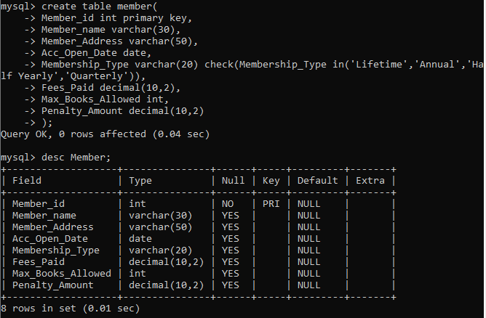

Q5) Alter Member table to increase Member_Name size from 30 to 40.
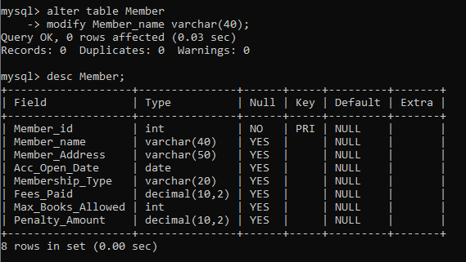
Q6) Add a column Reference (VARCHAR (30)) to Issue table.
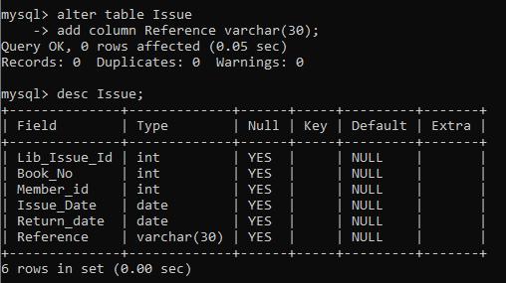
Q7) Drop the column Reference from Issue table.
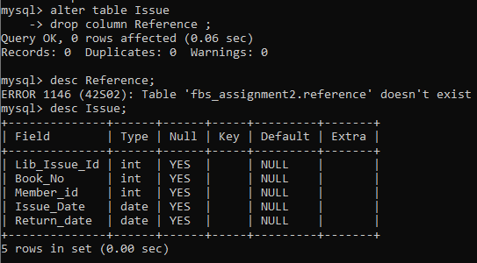
Q8) Rename the table Issue to Lib_Issue.

Q9) Insert the following records into Member table:
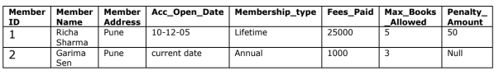
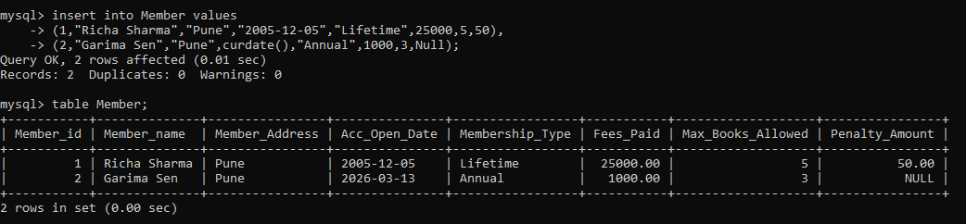
Q10) Insert at least 5 more records with suitable data into Member table.
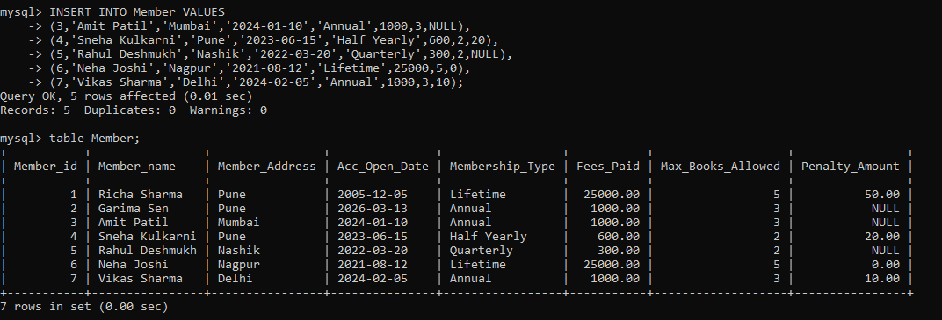
Q11) Try to decrease Member_Name size from 40 to 20 .If it fails, mention the reason.
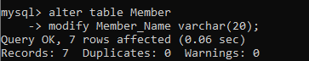
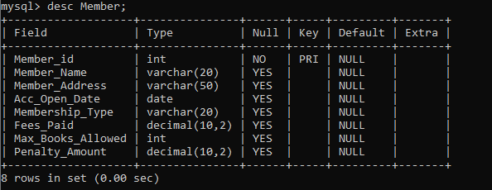
Q12) Add a CHECK constraint:
Max_Books_Allowed must be less than 100.
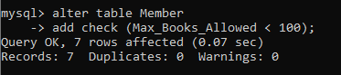
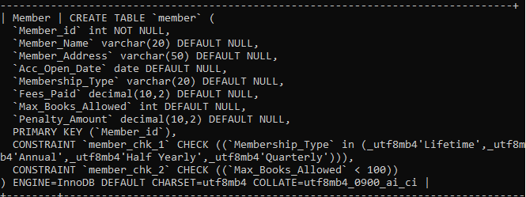
Q13) Create a backup table named MemberBackup using the Member table.
Use the following query:
CREATE TABLE MemberBackup AS
SELECT * FROM Member;
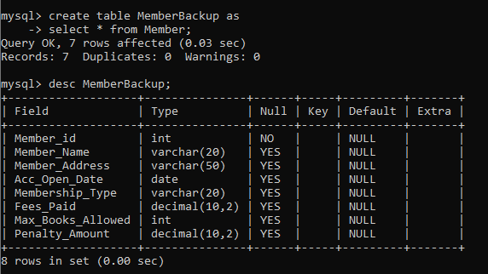
Q14) Add named constraints:
- Max_Books_Allowed < 100
- Penalty_Amount <= 1000
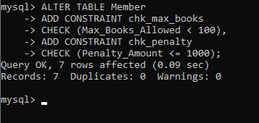
Q15) Drop the Books table.

Q16) Create Books table again with constraints:
- Book_No PRIMARY KEY
- Book_Name NOT NULL
- Category must be one of: ('System','Fiction','Database','RDBMS','Others','Science')
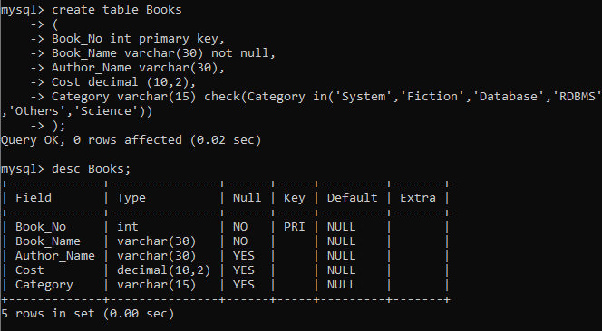
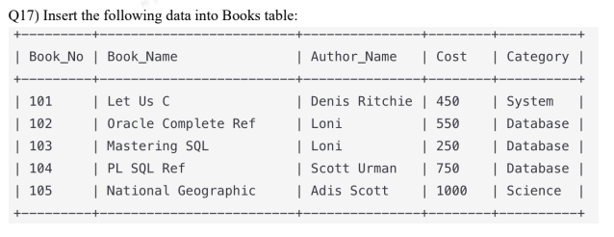
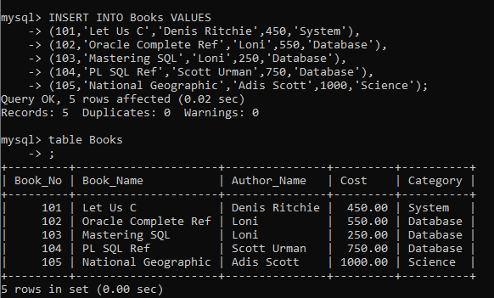
Q18) Insert at least 5 more records into Books table.
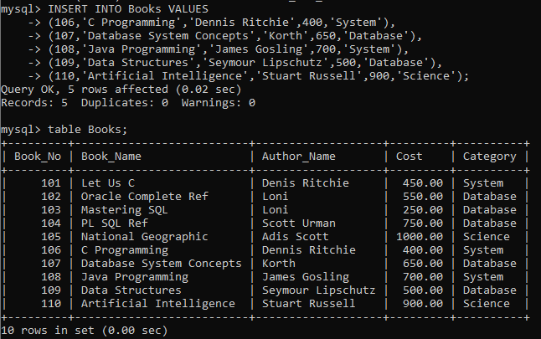
Q19) View all data from Member and Books tables using SELECT.
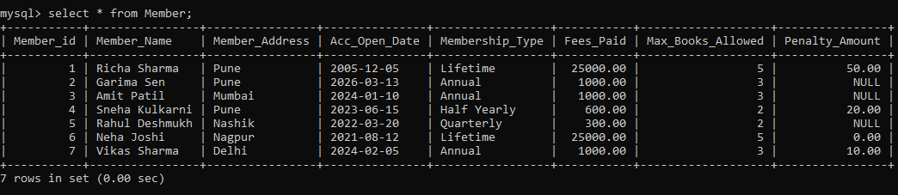
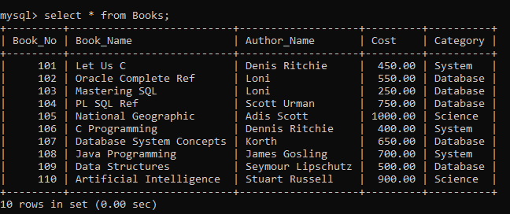
Q20) Drop Lib_Issue table.
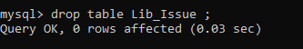
Q21) Create Issue table again with constraints:
- Lib_Issue_Id PRIMARY KEY
- Book_No FOREIGN KEY REFERENCES Books(Book_No)
- Member_Id FOREIGN KEY REFERENCES Member(Member_Id)
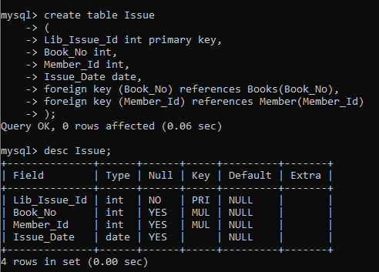
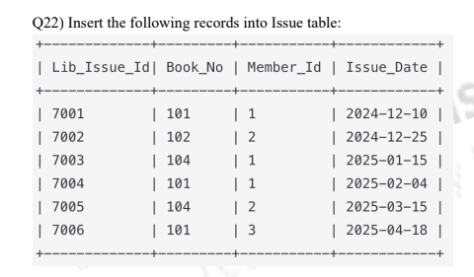

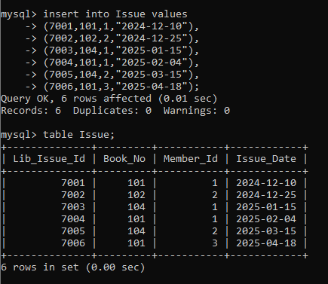
Q23) Try inserting an Issue record with Member_Id not existing in Member table.
Observe and write the error.
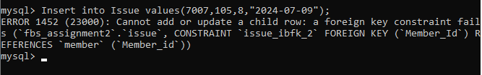
Q24) Try deleting Member_Id = 1 from Member table.
Observe and write the foreign key error.
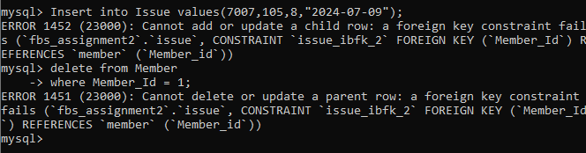
Q25) Update Return_Date for Issue_Id 7004 and 7005 to 15 days after Issue_Date.
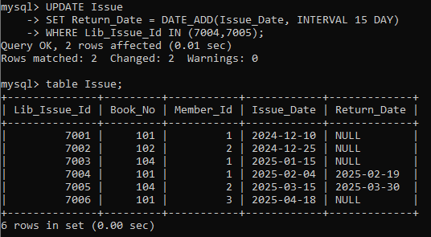
Q26) Delete all Issue records where Member_Id = 1 and Issue_Date is before '2006-12-10'.
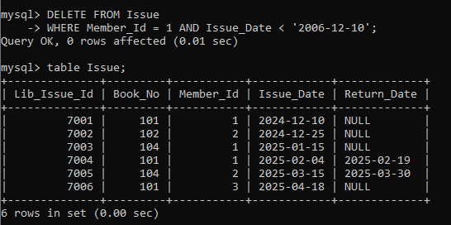
Q27) Delete all Books where Category is not Database or RDBMS.
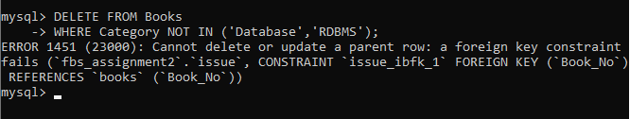

Q28) Drop all three tables: Issue, Member, Books.
